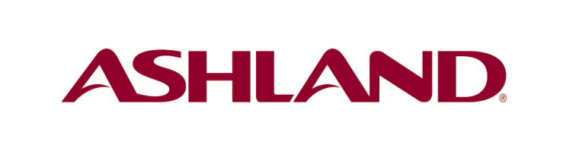
News Release

May 20, 2015

Ashland NatrostoneTM H30 receives Ringier 2015 Coatings Technology Innovation Award

Shanghai, China – Ashland Specialty Ingredients, a commercial unit of Ashland Inc. (NYSE: ASH), recently received a Ringier 2015 Coatings Technology Innovation Award for its NatrostoneTM H30 rheology modifier. It is the fifth consecutive year that Ashland has won a Ringier Innovation Award.

The Ringier Technology Innovation Awards recognize those who have made significant contributions for the advancement of the industry through technical innovation, improved productivity, economic efficiency and market opportunity creation. Ringier Technology Innovation Awards are regarded as one of the most important awards in China’s coatings industry.

Natrostone H30 rheology modifier, launched in late 2014, tackles the challenges faced by applicators in the fast-growing stone paint market. Using the new patent-pending technology, Ashland has developed this water-soluble polymer specifically to thicken liquid-applied stone paint and create the natural look and feel of stone.

Natrostone H30 provides excellent water whitening resistance both in short-drying time condition and low-temperature/high-moisture condition. H30 imparts stone paint with excellent application, better sprayability and stability, more efficiency for applicators; H30 also provides excellent storage stability, maintaining viscosity and phase separation consistency even at high temperature after storage.

“We are pleased that the innovative coatings work taking place within Ashland’s research and development labs has been recognized within the industry for a fifth consecutive year,” said William Zhao, general manager, Ashland Specialty Ingredients in Greater China. “We are committed to creating high-performance products that bring new value to our customers.”

“The launch of Natrostone H30 rheology modifier demonstrates our commitment to the fast-growing Chinese coatings market. We have an excellent technical and commercial global team that uniquely understands the market and our customers’ needs.” added Richard Cho, global marketing director, Industrial Specialties, Ashland Specialty Ingredients.

About Ashland Specialty Ingredients
Ashland Specialty Ingredients is the #1 global producer of cellulose ethers and a global leader in vinyl pyrrolidones. It offers industry-leading products, technologies and resources for solving formulation and product-performance challenges. Using natural, synthetic and semisynthetic polymers derived from plant and seed extract, cellulose ethers and vinyl pyrrolidones, as well as acrylic and polyurethane-based adhesives, Specialty Ingredients offers comprehensive and innovative solutions for today's demanding consumer and industrial applications. Key customers include: pharmaceutical companies; makers of personal care products, food and beverage companies; manufacturers of paint, coatings and construction materials; packaging and converting companies; and oilfield service companies. Visit ashland.com to learn more.

About Ashland
Ashland Inc. (NYSE: ASH) is a global leader in providing specialty chemical solutions to customers in a wide range of consumer and industrial markets, including architectural coatings, automotive, construction, energy, food and beverage, personal care and pharmaceutical. Through our three commercial units – Ashland Specialty Ingredients, Ashland Performance Materials and Valvoline – we use good chemistry to make great things happen for customers in more than 100 countries. Visit ashland.com to learn more.

- 0 –

™Trademark of Ashland or its subsidiaries, registered in various countries

FOR FURTHER INFORMATION:
Media Relations
Gillian Zhou
+86 (21) 2402-4881
gzhou@ashland.com

